Up: Dr. Michael Stiber's Home Page

CSS 457 - Digital Multimedia

Course Introduction
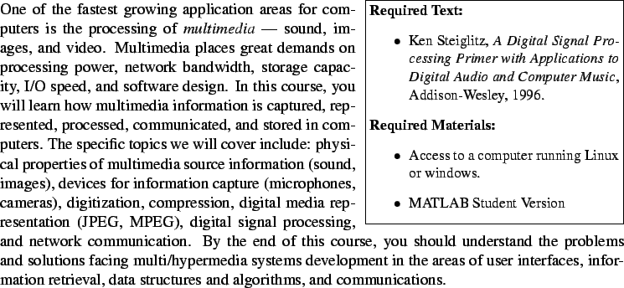

Course Objectives
By the end of this course, you should know:
- What multimedia signals are like in the ``real'' world and how their properties affect how we perceive them.
- How these signals are digitized and the tradeoffs among sampling speed, levels of quantization, and file size.
- How to perform simple signal filtering to remove noise, emphasize important features, etc. You should be well-prepared to work with electrical engineers in the design of more advanced signal processing systems.
- How multimedia file sizes can be reduced by compression, and the tradeoffs among compression, processing overhead, and media quality.

Prerequisites
It is expected that you have already taken CSE 143 and CSE 490A. While this course will not involve writing large quantities of code, I will assume that adapting to a new programming environment (MATLAB) will be no problem for you. This course covers much of the mathematical foundations for understanding signals and signal processing, however, it is assumed that you are familiar with topics such as complex numbers, trigonometry, derivatives, vectors, the basic idea of integrals, infinite series, and basic physics (mass, acceleration, force, etc).

Course Format
This course is divided into ten lessons. In each lesson, the relevant readings from the textbook are given, along with pointers to additional information. Lessons include self-test exercises scattered throughout, so I suggest that you go through all the material sequentially (or, at least, do the self-test exercises in each section). Each lesson concludes with a written or programming assignment to be submitted to your instructor for grading and feedback.

About the Textbook
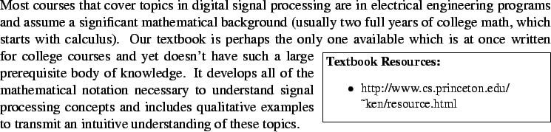
Because it is so focused, there are a few topics which it either doesn't cover to the depth we need or doesn't cover at all, these topics will be covered either with material on this course web site or material elsewhere on the web. I will also refer liberally to various supplementary readings throughout. You are invited to take the initiative to read them, but it is not required (in other words, they could also be called ``optional readings'').

About MATLAB
I will assume that you have purchased the student version of MATLAB (available at http://www.mathworks.com/products/studentversion/ or many campus bookstores for around $100) or have access to MATLAB on the University computers. Note that in the latter case, you will need to have an X Windows server on your desktop (either because you are running Linux, Mac OS X and XDarwin, or have purchased an X server for Windows). While in principle you could write your program in a language like C++ or Java, it would be considerably more work. Additionally, programs like Excel are not oriented to producing the kind of plots we need to do (they are targetted at business graphics) and the results are invariably disappointing.

Grading
You will receive a numerical grade (0.0 to 4.0) based on your performance on the assignments and exams. Each assignment is given equal weight to compute a homework average. Your final grade will be computed with the midterm and final each given 35% weight and homework given 30% weight.

Course Outline
Lesson | Topic | Reading
1 | Signals in the physical world | Ch. 1 & 2
2 | Signals in the computer | Ch. 3
3 | Intro. to filtering & feedforward filters | Ch. 4, 9 (§9)
4 | Feedback filters | Ch. 5
5 | The Fourier transform | Ch. 7, 8
6 | The z-transform and convolution | Ch. 9
Midterm Examination
7 | Application of the FFT | Ch. 10
8 | Compression basics
9 | Audio & video compression & coding
10 | Applications & course review | ch. 14
Final Examination

About the Course Developers

Michael Stiber, Ph.D.
Dr. Stiber is an Associate Professor in the Computing & Software Systems Program at the University of Washington, Bothell (where he is the principal investigator of the Biocomputing Laboratory) and an Adjunct Associate Professor in the Computer Science & Engineering Department at the University of Washington, Seattle. He received a BS in Computer Science and a BS in Electrical Engineering from Washington University, Saint Louis, in 1983, and his MS and PhD in Computer Science from the University of California, Los Angeles. His research interests include biocomputing and computational neuroscience.
Dr. Stiber has held positions with Texas Instruments (Dallas, Texas), Philips (Eindhoven, Netherlands), and the IBM Los Angeles Scientific Center. He was an Assistant Professor in the Department of Computer Science at the Hong Kong University of Science & Technology and a Research Assistant Professor in the Department of Molecular and Cell Biology at the University of California, Berkeley. He is a frequent visitor to the Department of Biophysical Engineering at Osaka University (Japan). He is a member of ACM, IEEE, Tau Beta Pi, and Eta Kappa Nu. He is on the executive committee of the Seattle section of the IEEE Computer Society, has served on organizing committees, chaired sessions, and reviewed papers for neural network and computational neuroscience conferences, and is a reviewer for Biological Cybernetics, Physica D, The Journal of Computational Neuroscience, and the Bulletin of Mathematical Biology.
When he isn't trying to make computers work more like brains, you'll most likely find Dr. Stiber working in his garden, planting some new perennial or harvesting some fruit or vegetables. He also enjoys being with his daughters and reading science fiction.

Bilin Zhang Stiber, Ph.D.
Dr. Stiber received a BS in Physics from Beijing Normal University (Beijing, China), and a MS and PhD from the Department of Biophysical Engineering, Osaka University (Osaka, Japan). She was an Assistant Professor at Osaka University and has frequently been a Visiting Scientist there. She was also a researcher at The Chinese University of Hong Kong, the Hong Kong University of Science & Technology, and the Electrical Engineering and Computer Sciences Department at the University of California, Berkeley. Her research interests lie in the area of signal processing theory and applications, especially time-frequency distributions and applications to speech and biosignals. She is presently a general partner in S-Squared Technical Consulting, specializing in data analysis and signal processing algorithm development. In her leisure time, she likes playing with her children, traveling, and watching movies.

About this document ...
Course Introduction
This document was generated using the LaTeX2HTML translator Version 2K.1beta (1.50)
Copyright © 1993, 1994, 1995, 1996, Nikos Drakos, Computer Based Learning Unit, University of Leeds.
Copyright © 1997, 1998, 1999, Ross Moore, Mathematics Department, Macquarie University, Sydney.
The command line arguments were:
latex2html -split 0 intro
The translation was initiated by Prof. Michael Stiber on 2002-01-31

Up: Dr. Michael Stiber's Home Page
Dr. Michael Stiber stiber@u.washington.edu

